TC20 LoadingPoint Application

Remark:

This application must be installed by IT department before can be used.

Getting started with the device:

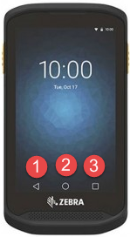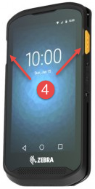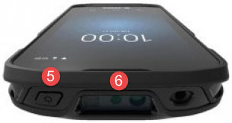

1. Previous activity
2. Main menu
3. View all open applications
4. Scan buttons
5. Start / shutdown /resume
6. Scan sensor

Application note:

The application collects the scan and stores it in sequences. You do not have to worry about sequences. The system itself manages the beginning and the end of the sequences.

A sequence can contain several codebars, by default the system is configured to collect two barcodes per sequence.



How to start the application?

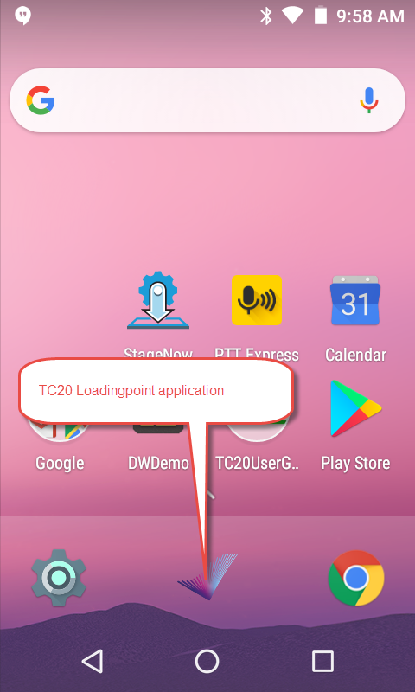

Attention

After to have started the application, if you see one of three screens, here below, this indicate that the application is not correctly configured. Please contact your IT department.

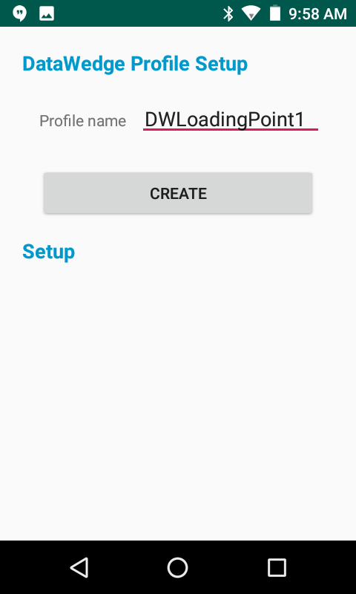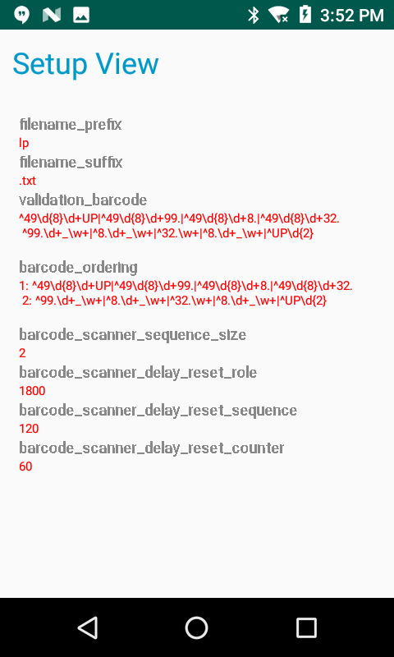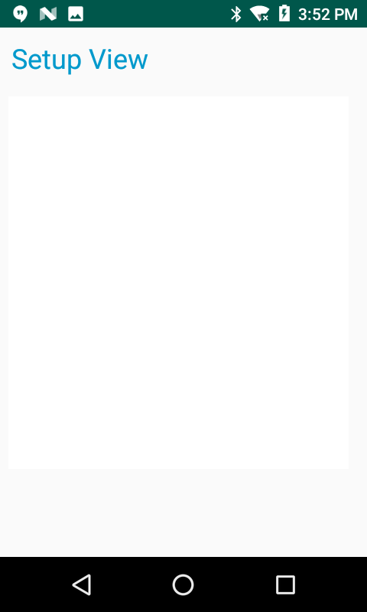

The input prompt:

The first screen indicate to you that it is necessary to scan your role number to access at the main screen.

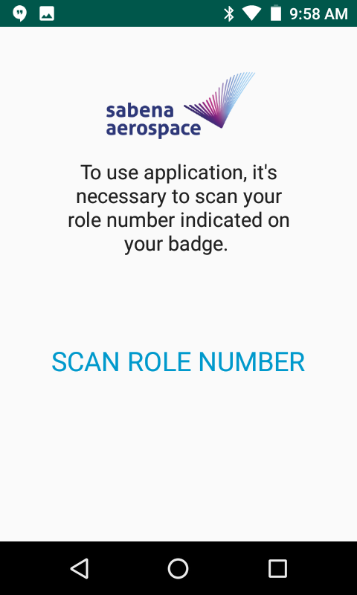

Main screen:

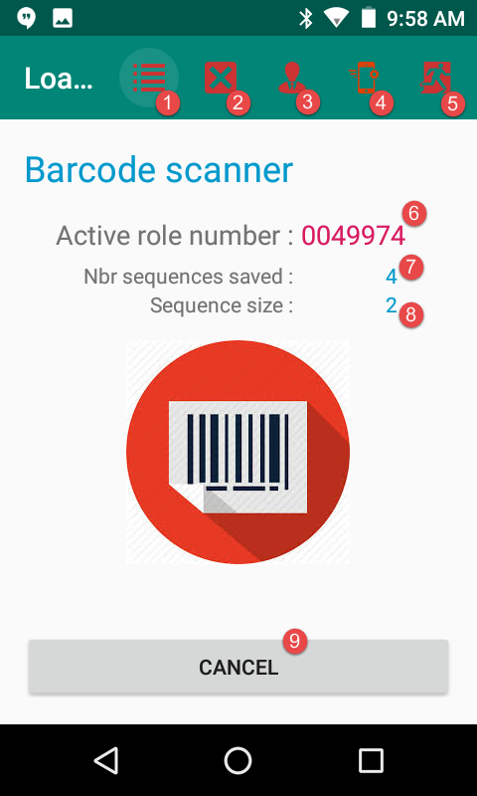

1. Access to the sequence management screen.
2. Delete all the sequences stored in the application.
3. Access to the DataWedge profile manager.
4. View application configuration details.
5. Exit the current screen.
6. Role number of the current user.
7. Number of sequence saved in the application.
8. Number of bars code by sequence.
9. Cancel the current sequence.

Follow the sequence

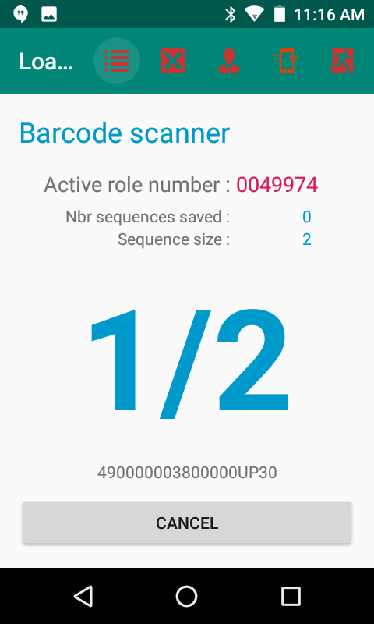 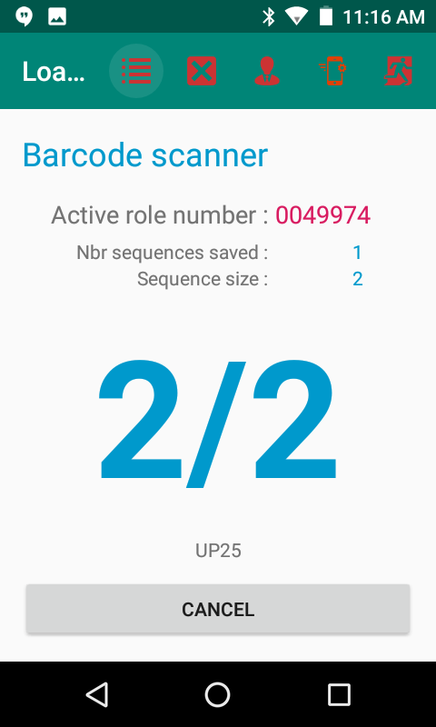

Delete all sequences:

If you want to delete all the sequences, a message will ask you to confirm this operation.

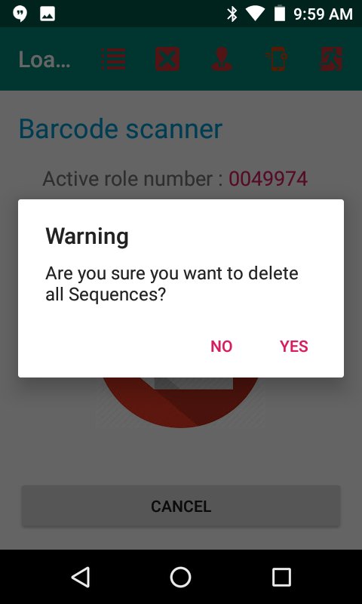

Sequence management:

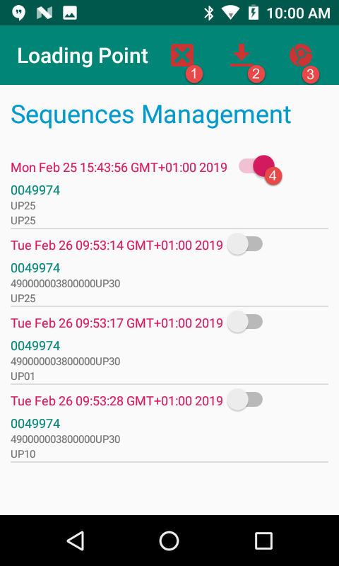 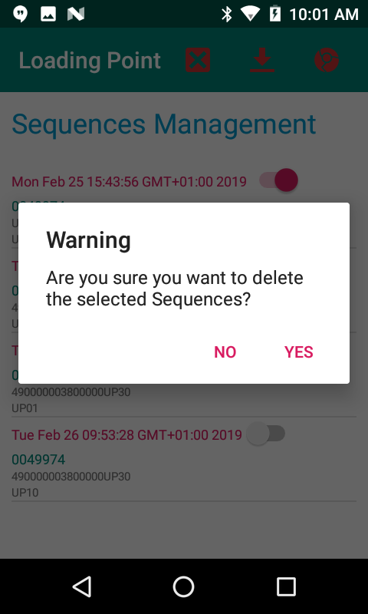

1. Delete the selected sequences using the switch (4).
2. Export the data to the accessible directory when the device is connected to a computer.
3. Export the data to the web server. For this, the device must be connected to the wifi with the SNAE sid.
4. Select the sequence to delete (1).